Date : 2025/04/14
Name: Siron Prajapati
Semester 2, Level 3 Computing 'Section A '

1.Write a program to take a number input from the user and display whether the number is even or odd.
Answer:
Code:
#Write a program to take a number input from the user
#and display whether the number is even or odd.

#Asking user to give input
print("\n Enter a number to find out it is odd or even? \n")
num = int(input("Insert any number: ")) #taking input and storing in 'num'

#checking odd or even
if(num%2==0): #to determine even number
print("\n The number {num} is even number!!")
else: #if not even number the program will display it as odd through else condition
print("\n The number", num, " is odd number!!")

Screenshot:
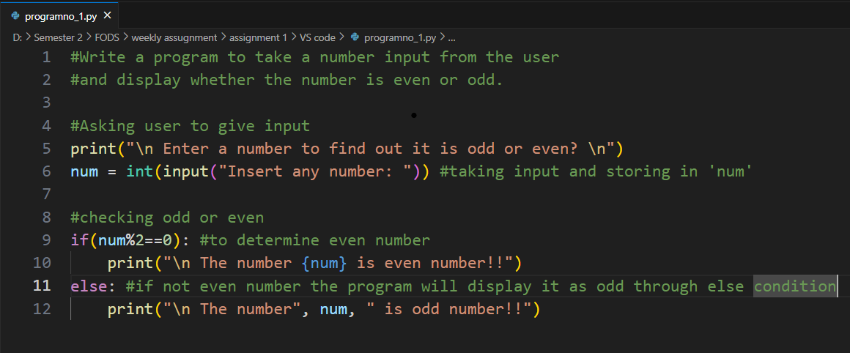

Output:
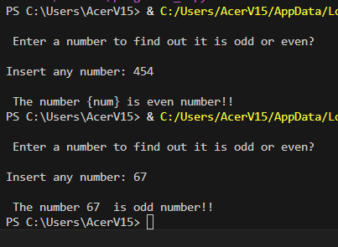
2. Write a program that prompts the user for two integer values and displays the results of the first number divided by the second, with exactly two decimal places displayed.

Answer:
#Write a program that prompts the user for two integer values
#and displays the results of the first number divided by the second,
#with exactly two decimal places displayed.

#Prompt the user for 2 integer values
print("\n Enter any 2 numbers for their division: ")
num1 = int(input("\n The First Number : ")) #taking 1st number input
num2 = int(input("\n The Second Number : ")) #taking 2nd number input

#program to calculate division
div = num1/num2

#printing the result of the user input with exactly two decimal places displayed.
print(f"The result of {num1} divided by {num2} is {div:.2f}")

Screenshot:
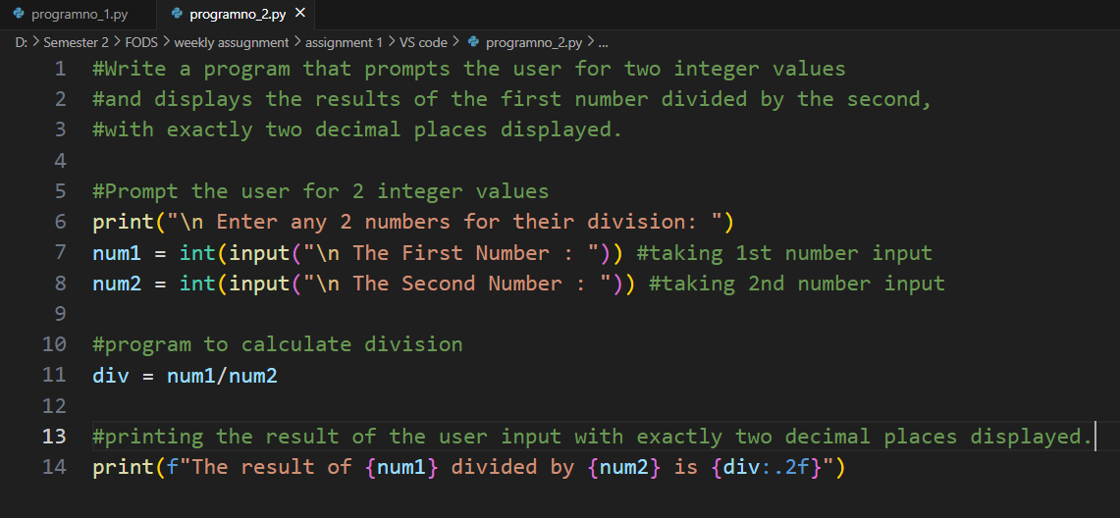
Output:
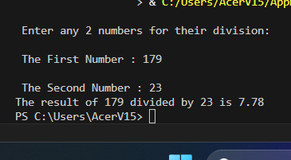

3.Write a program that will convert Celsius value to Fahrenheit.
Answer:
Code:
#Write a program that will convert Celsius value to Fahrenheit.

#taking celsius value from user
print("Enter a celsius value to convert into fahrenheit: \n")
celsius = int(input("Celsius value = ")) #storing user input in variable 'celsius'

#Program to convert Celsius value to Fahrenheit.
fahrenheit = (9/5)*celsius+32

#Displaying the fahrenheit value
print(f"\n {celsius}°C is equal to {fahrenheit:.2f}°F")

Screenshot:
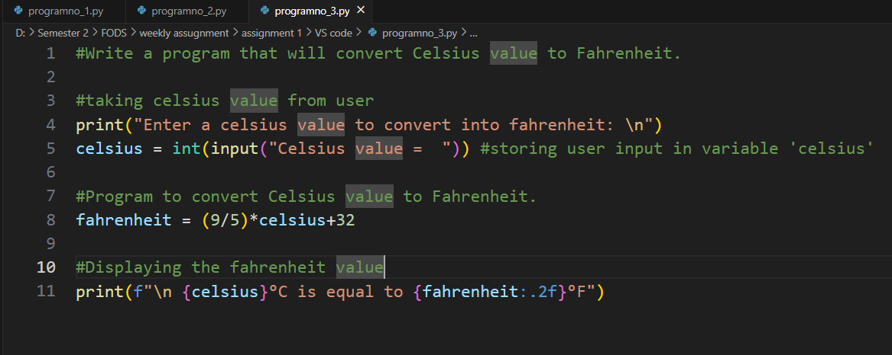

Output:
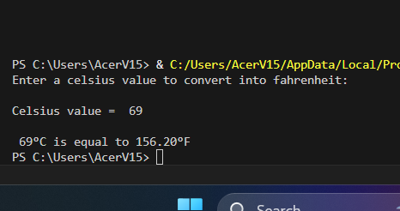

4. Write a program to find the Euclidean distance between two coordinates. Take both the coordinates from the user as input.
Answer:
Code:
#Write a program to find the Euclidean distance between two coordinates.
#Take both the coordinates from the user as input.

#Taking both the coordinates from user as input
print("Finding the distance between two coordinates: \n")
x1 = int(input("First coordinate of the first point: "))
y1 = int(input("\n Second coordinate of the first point: "))
x2 = int(input("\n First coordinate of the second point: "))
y2 = int(input("\n Second coordinate of the second point: "))

#importing math to find out square root
import math

#program to calculate the Euclidean distance
a =(x2-x1)**2
b=(y2-y1)**2
result = a+b
Euclidean_distance = (math.sqrt(result)) #using math.sqrt from the above import maths

#displaying the Euclidean distance in correct format
print("The Euclidean distance between two coordinates a(",x1,",",y1,") and b(",x2,",",y2,") is ",Euclidean_distance)

Screenshot:
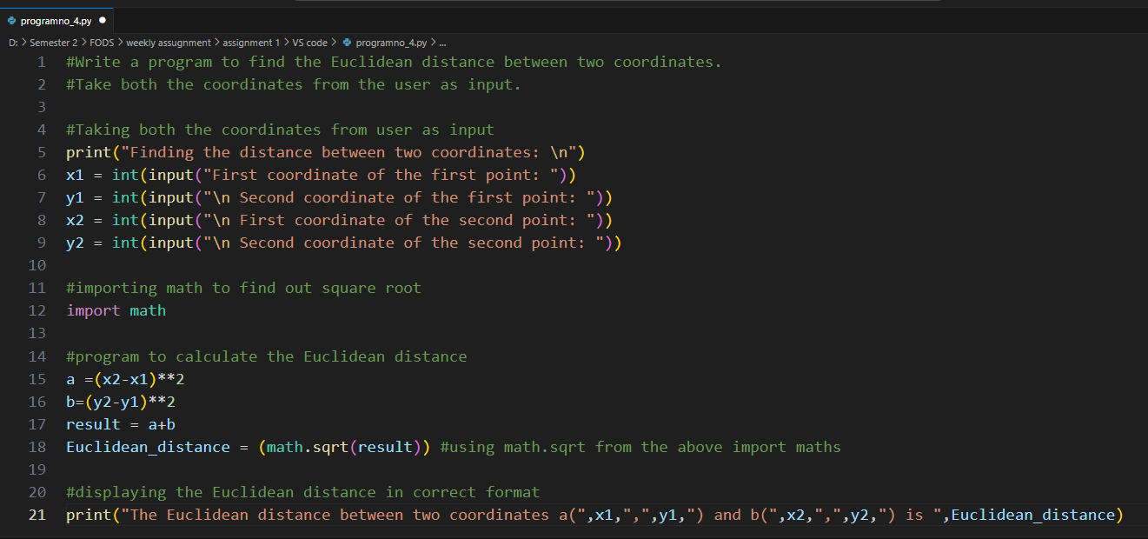

Output:
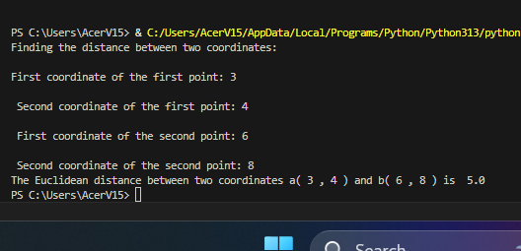

5. Write a program to find the simple interest when the value of principle, rate of interest and time period is provided by the user.
Answer:
Code:
#Write a program to find the simple interest when the value of principle,
#rate of interest and time period is provided by the user.

#Taking user input for principle, interest, and time period
print("Calculating The Simple Interest\n")
P = int(input("Value of Principle: "))
T = int(input("\n Time Period: "))
R = int(input("\n Rate of Interest: "))

#Calculating simple interest
Simple_Interest= (P*T*R)/100

#Displaying Output
print("The simple interest is ",Simple_Interest)
Screenshot:
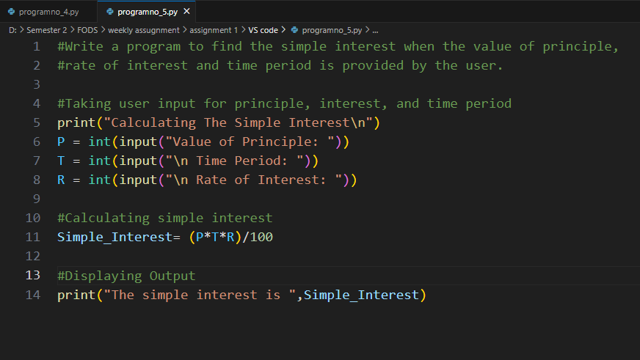

Output:
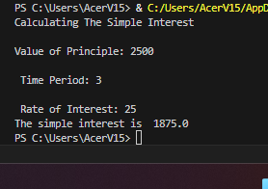

6.Write a Python program to find those numbers which are divisible by 7 and multiple of 5, between 1500 and 2000 (both included).

Answer:
Code:
#Write a Python program to find those numbers which
#are divisible by 7 and multiple of 5,
#between 1500 and 2000 (both included).

#declaring value of a and b
a = 1500
b = 2000

#Displaying so that user could understand
print("The number divisible by 7 but are not a multiple of 5 are ")

#for loop
for i in range(2000,3201 + 1): #checking all numbers from 2000-3200
if i%7 == 0 and i%5==0: #condition for checking the divisible of 7 and multiple of 5
print(i) #printing all the outputs

Screenshot:
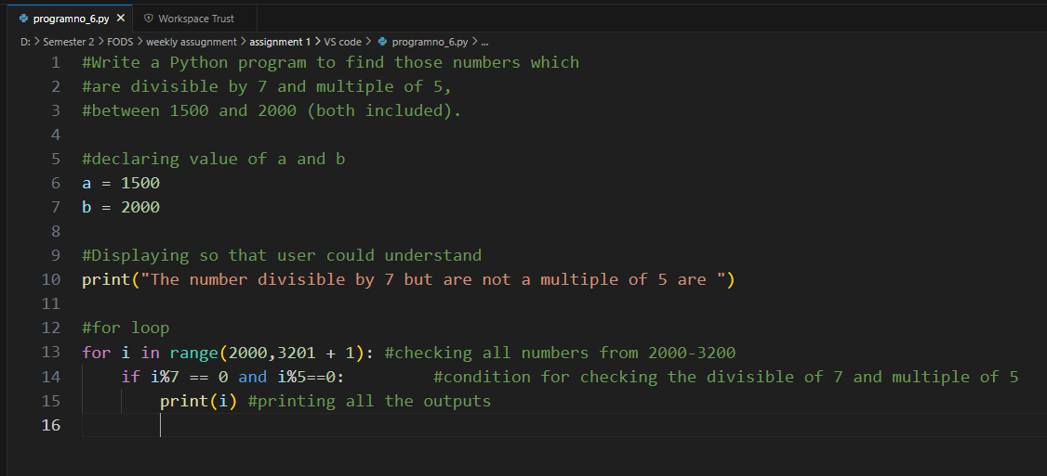
Output:
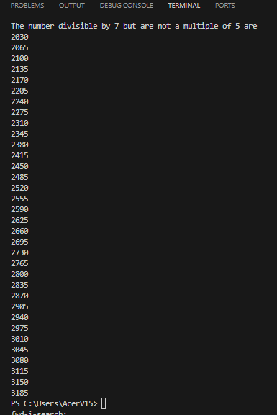

7. Write a Python program that accepts a string and calculates the number of digits and letters.

Answer:
Code:
#Write a Python program that accepts a string
#and calculates the number of digits and letters.

#taling input from user
string = (input("Enter a string: \n")) #storing input in variable "string"

#creating a function
def counting(string):

count_letter = 0
count_digits = 0
#initializing count of letter and digit as zero

for char in string: #for loop to check
if char.isalpha(): #to find if the string are letters
count_letter += 1
#increasing count value

elif char.isdigit():#to find if the string are letters
count_digits += 1
#increasing count value

else:
print("Invalid Input!!!") #if wrong input is given

print("Number of Letters: ",count_letter)
print("Number of digits: ",count_digits)
#printing the final count of letters and digits

counting(string)#calling the function

Screenshot:
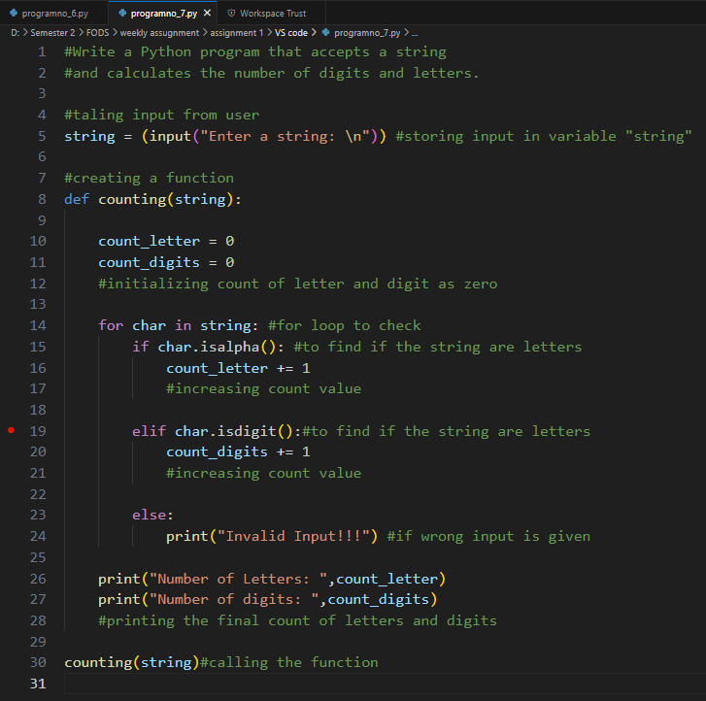

Output:
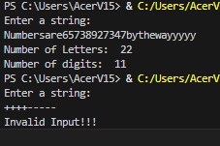

8. Write a program to create a number guessing game for the user. The program should ask the user to input a number.
Answer:
Code:
#Write a program to create a number guessing game for the user.
#The program should ask the user to input a number.

#importing random number
import random

#creating a function
def num_guess():
n=random.randrange(1,25) #range for random number import

attempts = 5 #maximum attempts=5

print("-------------------------------------------")
print("----WELCOME TO THE NUMBER GUESSING GAME----")
print("-------------------------------------------")
print("I have selected one number from 1 to 25.You have to guess than number in 5 attempts")
#displaying about the game

#for loop to let user only do 5 attempts
for attempts in range(1,attempts+1):
guess=int(input("Enter your guess: "))
#input number from user

while guess!=n: #while loop until the guess is wrong
if guess<n:
print("Too Low")
guess=int(input("Enter another guess: "))
#if guess is lower than the random number

elif guess>n:
print("Too High")
guess=int(input("Enter another guess: "))
#if guess is higher than the random number

else:
break
print("Correct number")
#Breaking the while loop if the guess is correct

#if the user have reached maximum attempts
if attempts==attempts:
print("Game Over!!")

#calling function to execute program
num_guess()

Screenshot:
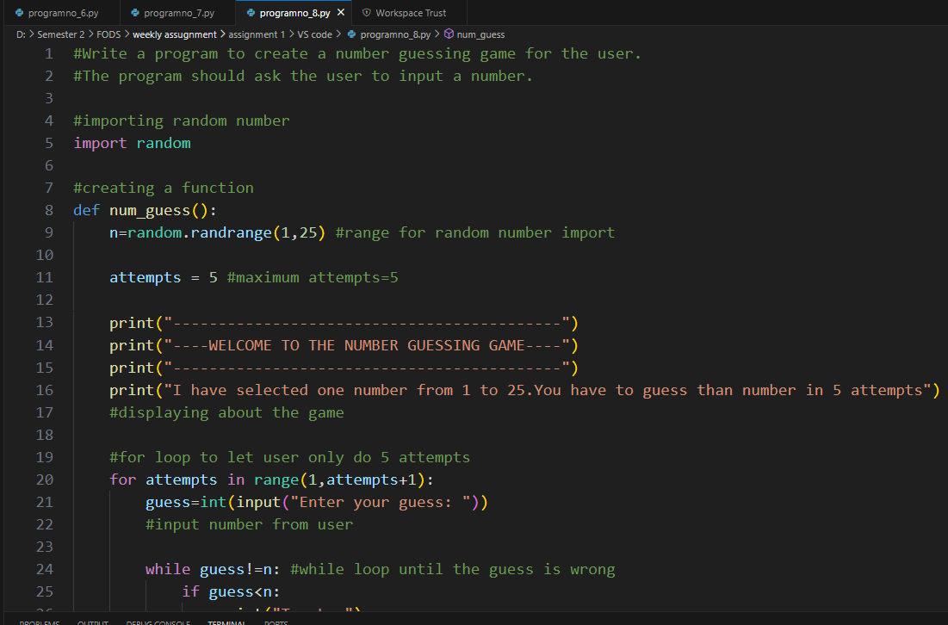
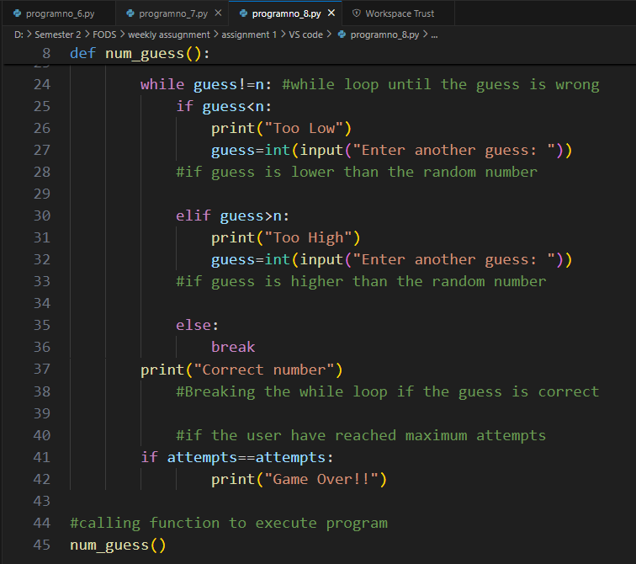

Output:
